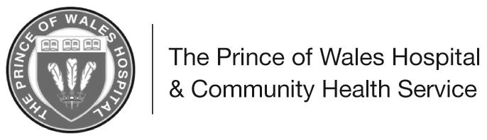
Information for patients
and relatives
Cardiac Surgery

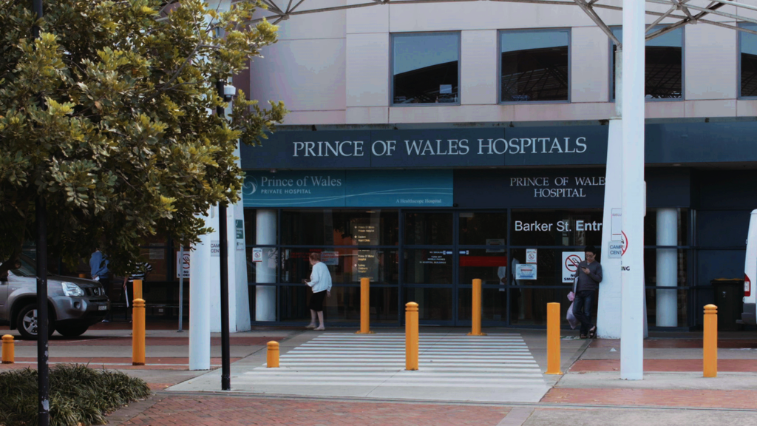

Cardiac Surgery
This information booklet is designed to help you and your family prepare for your heart surgery. The aim is to inform you of the pre-operative tests that may be required, the different types of surgeries performed, and how to support your recovery.

This booklet is a guide only. It should not replace advice from your local doctor (GP), cardiologist or surgeon.

Please always seek medical attention from your GP or local hospital if you are concerned about your own, or your relative’s wellbeing.

Table of Contents Page no

Types of surgery 4

Preparing for your surgery 6

What you can do to prepare for surgery 8
Accommodation and transport 9

The day of surgery 10

After your surgery 11

Ward information 11

Immediately after your surgery 11

Physiotherapy 13

Going home 16

Exercises to do at home 21

More information 24

TYPES OF SURGERY
Most heart surgery requires a cut to be made down the centre of your chest to get to the heart. A heart lung bypass machine will be used to do the work of your heart and lungs while the surgeon operates on your heart. Coronary artery bypass and heart valve surgery are the most common types of surgery performed.
Coronary artery disease: The coronary arteries supply blood and nutrients to the heart. Coronary artery disease causes the arteries to progressively become blocked from plaque containing cholesterol and fibrous tissue. This reduces the blood supply to the heart and therefore the amount of oxygen reaching the heart muscle. The pain associated with this is referred to as angina.
Coronary artery bypass surgery (CABG): This surgery involves the use of blood vessels to bypass blockages in the coronary arteries. An artery from behind your chest wall or arm; or vein from your leg are used to bypass the blockages in your heart.
Picture 1
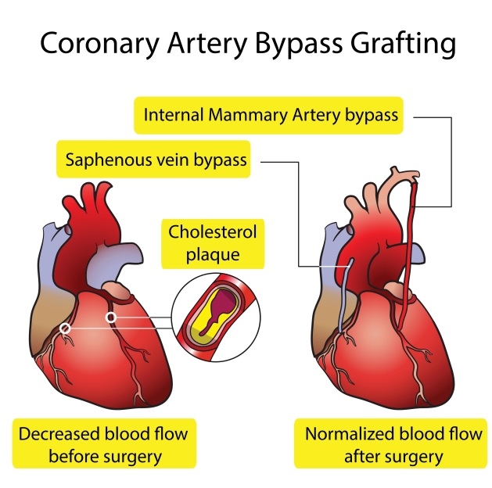

Off Pump Coronary Artery Bypass (OPCAB): This approach is like traditional open-heart surgery because the chest bone is opened to access the heart, however, the heart is not stopped, and a heart-lung bypass machine is not used. Off-pump heart surgery is not appropriate for all patients. Your particular heart problem, age, overall health, and other factors that may affect the surgery determine what is best for you.
Heart valve disease: Heart valves may be damaged by infection or disease. Rheumatic fever is a common cause of valve disease. Some people are born with faulty valves (congenital defects), some of which require immediate surgery; others are fixed later in life.
Heart valve surgery: There are 4 valves in the heart, the aortic, mitral, tricuspid and pulmonary. Valves can become thickened and narrowed (stenosis) or my fail to close properly (incompetence) which leads to backward flow of blood (regurgitation). The surgeon may use a ring to support the valve, repair the leaflets on the valve, or replace the valve completely. Your surgeon will discuss with you the specific surgery required and the merits of the different types of valves available.
Picture 2 Valves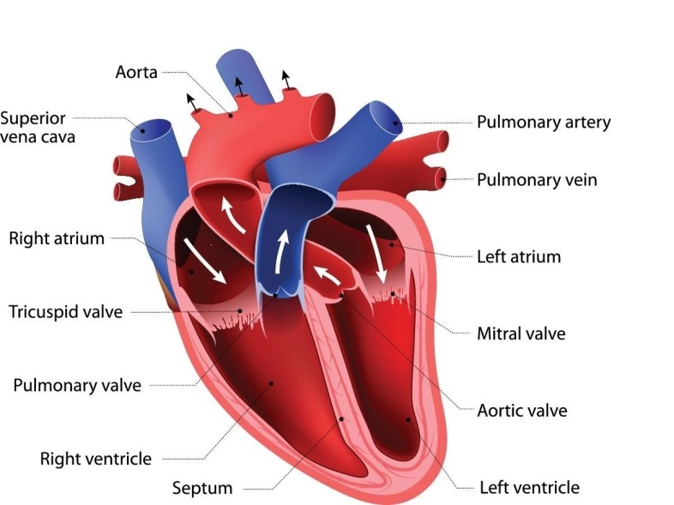

Atrial and Ventricular septal defects: An atrial septal defect is an opening in the wall which divides the upper chambers of the heart (atria). This opening allows extra blood to go to the lungs and therefore may increase the work of the heart. A ventricular septal defect is an opening in the wall between the lower chambers of the heart (ventricles). These defects may be stitched together or may require the use of a synthetic patch to close it.
Heart aneurysms: A weakness in the heart muscle can cause a bulge (aneurysm), which often occurs as a result of a heart attack. The heart will not pump as effectively with this weakness or ballooning. Aneurysms are corrected by reinforcing or patching the weakened area.
If the aneurysm occurs in the aorta, a synthetic material known as a Dacron graft may be used to replace the damaged section of the artery.

PREPARING FOR SURGERY
Pre-admission clinic: If you are well enough and your surgeon recommends it, you will be asked to attend the pre-admission clinic to prepare for your surgery. This is done the week or even the day before your surgery. Once you have attended the clinic you need only be admitted to hospital on the day of your surgery.
There are a number of tests that need to be completed prior to your surgery, and these need to be organised by your GP and brought with you to the pre-admission clinic. These include a chest x-ray, and blood tests. Please wait until we have talked to you before having these done.

If you are having heart valve surgery, you need to see your dentist and have your teeth checked prior to surgery. Please bring your dental clearance form to the pre-admission clinic.

On the day of the pre-admission clinic you will:
- Have an electrocardiogram (ECG)
- Have a breathing test called spirometry
- Sign your consent form for the surgery.

Either during the pre-admission clinic, or the day before your surgery (if you are already in hospital) you will be seen by the following people:

Nursing staff will take a brief history of your past and present health status. Your blood pressure, pulse, temperature and weight will be recorded. A urine sample and skin swabs will be taken for routine analysis.

The Doctor will take a full medical history and perform a physical examination. This will involve routine blood tests (different to the ones your GP organised), and any other necessary investigations. A doctor called a cardiothoracic registrar will explain the operation and ask you to sign a consent form. Be sure that you understand the operation and ask questions before signing.
The Anaesthetist will discuss your anaesthetic with you. It is important that you let them know if you have had any problems with previous anaesthetics. The anaesthetist will advise you of when to fast (stop eating and drinking) and what if any medicines to have on the day of your surgery. They will also discuss post-operative pain relief with you.

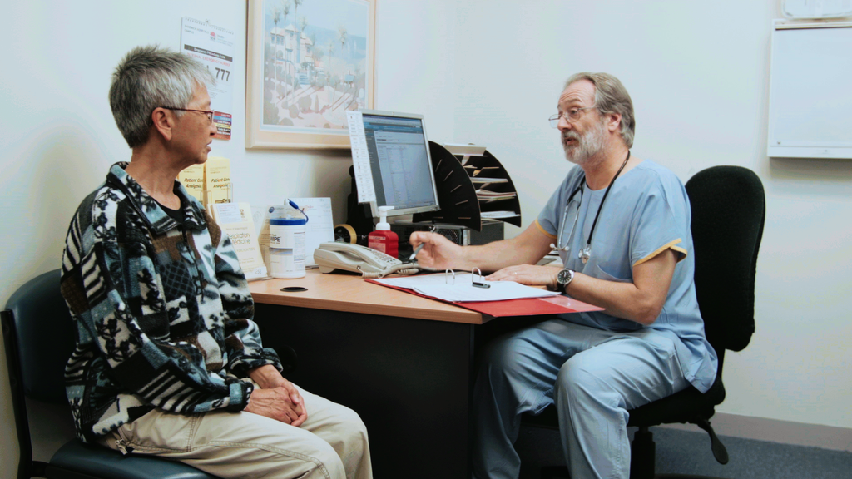

The Physiotherapist will assess your lung function. They will give you instructions on breathing exercises to do after the operation, and how to protect your sternal wound when coughing and moving.

A surgical dresser or nurse will use electric clippers to remove hair from your chest and other areas. This is done because the operation site needs to be hair free to decrease to risk of infection.

What you can do to prepare for your operation

Preparing for cardiac surgery: Recovery from cardiac surgery depends on many factors. There are two you have total control over:

♥ Stop smoking. Smoking drastically increases the risk of post-operative complications after surgery. Your GP can help you with this. Your local chemist can advise about nicotine replacement therapy or call the national Quitline on 131 848. There is also a smoking clinic in the department of respiratory medicine at Prince of Wales Hospital. (Ph: 9382 4641)
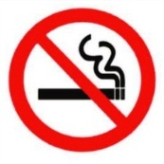

There is a no smoking policy in all NSW public hospitals. If you were smoking prior to surgery, and are having difficulty stopping please inform staff so we can provide you with nicotine replacement therapy (patches, gum).

♥ Have a positive attitude. This will aid healing, and help to decrease your time in hospital. It is expected that by the time you leave hospital you will be able to shower, dress yourself, perform your deep breathing and coughing exercises and move around independently, even though you are likely to be slower than usual, and tire more quickly.

Please plan for your surgery including:

♥ How you will get your pre-operation tests organised
♥ How you will get home from hospital
♥ Arrange to have someone at home with you for 2 weeks after you leave hospital
♥ Organise help with your shopping, laundry, housework etc.
♥ Arrange leave from work if necessary
♥ Bring a good book or magazines to read while you are in hospital
♥ Female patients should bring a comfortable wireless bra to wear after the operation

Accommodation and transport
You are expected to make your own arrangements to get to and from hospital for your surgery. If you need to travel to Sydney before the admission date and are unable to stay with relatives or friends, then you may want to consider the following:
The Sydney Lodges Randwick | www.sydneylodges.com/locations/randwick/
Avoca Lodge | 9399 7779
High Cross Park Lodge | 9314 5553
Perouse Lodge | 9314 6686
St Marks Lodge | 9310 0752
The Blenheim | 8345 8400
The Randwick Lodge | 9310 0700
Elizabeth Hunter Lodge | www.wmhw.org.au  9369 0307
The Royal Hotel | www.royalhotel-sydney.com  9399 3006

There are other options in the area, please ask if you need more information.
If you live 100km or more away from Prince of Wales Hospital, you may be eligible to claim back your travel expenses through the Isolated Patients Travel and Accommodation Assistance Scheme (IPTAAS). Your GP or referring specialist can provide you with a form about this.

There is a travel agent within walking distance from the hospital for relatives to book flights home if required.

Please note that it is airline policy not to fly for 10 days after having cardiac surgery. Please keep this in mind when planning how and when you will get home as you will probably be discharged from hospital before this time.

THE DAY OF SURGERY

You will be asked to shower the night before, and the morning of surgery using antibacterial soap which we will give you. Do not use talcum powder, deodorant, or perfume. On the morning of your operation you will be asked to put on a hospital gown, (ties go to the back).

The nursing staff will provide a plastic bag for you to put a pair of pyjama’s (or nightie), toiletries, dentures, hearing aids, glasses. All these items will go with you to intensive care.

Jewellery, nail polish, dentures, hearing aids must be removed before you leave the ward for surgery. Please leave valuables at home.

The time from when you leave the ward to go to the operation to the time of arrival in intensive care after the surgery will be approximately 6-7 hours. This includes time for the anaesthetist to insert intravenous lines and breathing tube, as well as the actual surgery

Unfortunately, your surgery may be postponed due to an emergency. We try to avoid this happening but please be aware that if it does occur, it is beyond our control.

WARD INFORMATION

♥ The use of mobile phones is not allowed in the ward as they can interfere with monitoring equipment.

♥ Please inform nursing staff if you intend to leave the ward at any time in case a test has been booked. You must not leave the ward while you are on a cardiac monitor.

♥ Although support from family and friends is important, rest after surgery is essential. For this reason we ask all visitors to please respect the visiting hours. If other times are needed, this can be discussed with the nursing unit manager (NUM).

Our visiting hours are:
10am – 1pm
3pm – 8pm

We also ask that only 2 people visit at any one time due to space restrictions in the rooms. Children 12 years and under are not permitted in the Cardiothoracic Intensive Care Unit.

AFTER YOUR SURGERY

Immediately after your surgery

You will spend at least one night in the intensive care unit (CTICU) which provides specialised care and monitoring. You will have one nurse dedicated to looking after you.

As you wake up, you will hear many different noises including alarms from monitoring equipment and people talking. You will have a breathing tube in your mouth attached to the ventilator helping you breathe. Once you are awake enough and can breathe for yourself, this tube will be removed.

The day after your operation, if you are well enough, you will be transferred out of intensive care to the ward (Dickinson 3 South). You will be sitting out of bed, and will still have an intravenous (IV) line in your neck or upper chest area and a catheter in your bladder. You may also still have chest drains and pacing wires in your chest.

As soon as possible after surgery you will be helped out of bed to sit in your bedside chair. This keeps your muscles moving and prevents lung problems such as pneumonia, which can occur from staying in bed.
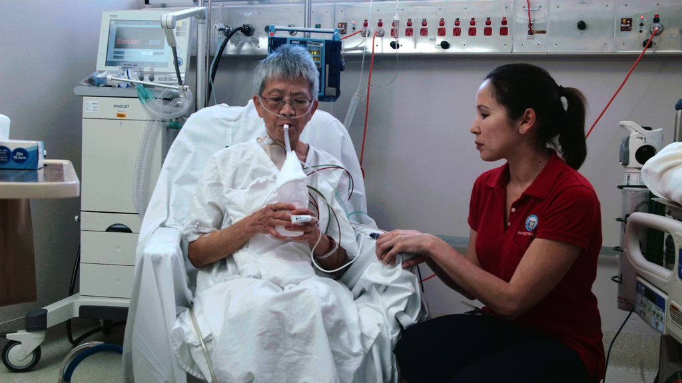

Anti-embolism stockings: These improve circulation and help to prevent blood clots from forming in your legs. You will start wearing the stockings on the 2nd day after surgery and you will need to continue to wear them for 6 weeks.

Pain relief (analgesia): Some pain after the operation is inevitable, the most common areas being where your wounds are on your chest and leg, your shoulders or neck. When you are in intensive care you will receive pain relief through your drip, and then as you move through the recovery process the type and strength of pain medicines used will reduce.

You will need pain relief so you can do your physiotherapy exercises. These exercises are essential to your recovery and will affect the length of time you have to stay in hospital, so please take your pain medicines regularly.
Constipation: This is very common after an operation due to reduced mobility and the pain medicines. Your nurse will offer you laxatives to help you with this.
Irregular heart beat: It is common after cardiac surgery to develop an irregular heartbeat. This is detected through cardiac monitoring. Usually this is temporary and gets better after taking your medicines.
You may also have some special wires attached to a “pacing box” to help regulate your heartbeat. These will be removed before you go home.

Wounds: Your chest and leg wound will remain covered while you are in hospital, when you go home they can be left uncovered and cleaned in the shower using mild soap. Please check your wounds daily, if there is any sign of redness or fluid leaking see your GP.
Stitches: Your chest and leg wounds are closed using stitches that dissolve on their own. You will have 2 or 3 black stitches from where your drains were, which will be removed before you go home. Occasionally clips are used in some wounds. If you have clips you may need to see your GP after going home to have them removed.

PHYSIOTHERAPY

Your recovery from cardiac surgery depends on effective physiotherapy.

Physiotherapy maximises the functioning of your lungs by:
- Helping to remove fluid from your lungs
- Improving air distribution within your lungs
- Preventing your lung from collapsing
- Preventing pneumonia or chest infections

Physiotherapy consists of breathing exercises, arm exercises, and walking.

Breathing exercises

These exercises use the ‘active cycle of breathing technique’.
This involves using certain breathing manoeuvres in the following order:
- Normal breathing
- Deep breathing
- Normal breathing
- Huffing
- Cough

The order is important to improve airflow and remove the fluid on your lungs.

What you need to do:

Normal breathing | Sit comfortably in an upright position. Breathe in slowly. Let your abdomen swell slightly as you inhale and keep your shoulders relaxed. Breathe out gently. Repeat 3 or 4 times.

Deep breathing | Take a deep breath in, keep inhaling for 3-5 seconds, even if your lungs feel full try to keep breathing in. Breathe out slowly. Repeat 3-5 times.

OR

Inspiratory hold | Breathe in as deeply as possible, directing the air to the bottom of your lungs, hold your breath for 2-3 seconds then breathe out slowly. Repeat 3-5 times.

Huff | Take a medium size breath in. Then with your mouth half open, force the air out while making a soft “haa” sound (like when you breathe on glasses to clean them).

Cough | Take a deep breath then cough. One good strong cough per cycle is more effective than repeated little ones. Use a folded towel against your chest to help prevent pressure on your sternal wound when you cough.

If you feel dizzy doing any of these exercises then stop. You may be taking too many deep breaths one after the other. Have a rest then try again with fewer repetitions.

The physiotherapist will show you how to do these exercises before you have your surgery.

Arm exercises

- Lift both your arms forward and raise them toward the ceiling. Hold for a few seconds then lower them

- Lift both arms sideways away from your body until they are parallel to the floor. Hold for a few seconds, than lower them gently.

Continue with these exercises, as pain permits, until you are back to the range of movement you had before the surgery.

Walking

It is important to walk regularly after your surgery. We will get you walking the day after your surgery. Your physiotherapist will walk with you until you are able to do it alone. They will let you know when you are able to walk by yourself.

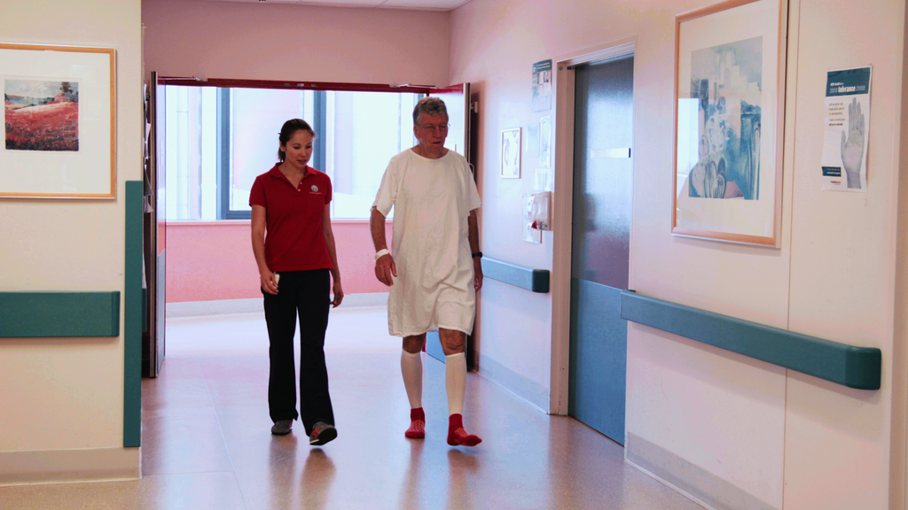

GOING HOME

You will be well enough to go home about 5-7 days after your operation. Exactly when you are discharged from hospital will vary depending on how well you are recovering. Arrangements should be made with your family or friends to collect you from hospital. Ask them to bring a small pillow or towel wrapped in a pillowcase for the journey home. Place this between your chest and the seatbelt to reduce any discomfort. Please remember that a seatbelt must always be worn when travelling in a car.

We usually ask for people to be collected at 10am. If this is not possible please let the nursing staff know. If you need any extra help at home please let the nursing unit manager know as soon as you can so we can organise this for you.

It is important that you follow up with your GP during your first week at home and give him/her the discharge letter we will give you before you leave hospital.

You also need to see your cardiologist and your surgeon about 6 weeks after surgery. You will be given the surgeons appointment before you leave hospital, but you will need to make your own appointment with your cardiologist.

One week prior to the appointment with your surgeon you will need to see your GP to organise a chest x-ray, ECG, and referral. Please take these to your surgeon’s appointment.

Long term management of your health requires your active participation. Rest is very important, for example, ensure you have a rest every day after lunch for at least one hour, but remember that long periods of inactivity will make you feel stiff and sore so it is important to balance rest and activity.

You may also find that everyday tasks that you used to do are more tiring now, so it is important to take regular breaks and gradually increase your activity level until you return to the same level of activity you were doing before your operation.

Cardiac Rehabilitation: The World Health Organisation and Heart Foundation recommends people participate in a cardiac rehabilitation program after heart surgery. We will help you find a program near your home. Cardiac rehabilitation includes supervised exercise, information, counselling, and support during your recovery, and to assist in making lifestyle changes where necessary. Cardiac rehabilitation offers lifetime benefits. Here are some testimonials from people who have attended the Prince of Wales Hospital cardiac rehabilitation program:

“The program has given me confidence and I feel stronger.”

“I was confused. Now I’m clear and confident.”

“Very good holistic program. Covers all aspects in an easy to understand manner. I felt motivated and comfortable.”

For any enquiries about the Prince of Wales Hospital (POWH) Cardiac rehabilitation program telephone 9382 2286

Please register for POWH cardiac rehabilitation through the Northern Network Access Referral Centre on 9369 0400.

Medicines: Your medicines may change while you are in hospital. The hospital pharmacy will let you know of any changes you need to make and supply you with 5 days of any new medicines. You will need to see your GP within 5 days to get a new prescription.

You may be given a medicines list when you leave hospital. Continue to take only the medicines on this list. If you are unsure about what medicines to take then take our medicines and your medicines list with you to your GP or pharmacy. It is important to keep your medicines list up-to-date.

Warfarin – You may be prescribed warfarin if you have had valve surgery to prevent blood clots forming on or around your new or repaired heart valve. The dosage will be closely monitored through regular blood testing. To maintain proper levels in your blood, please take your medication as prescribed and have follow up INR blood tests as advised. When you leave hospital you will be provided with a book to record your INR levels, please take this book with you when you see your GP.

Wound Care and discomfort: You will continue to experience some discomfort for at least 2-3 weeks after surgery. Most pain will be relieved with Paracetamol (e.g. Panadol ®) or Paracetamol in combination with codeine (e.g. Panadeine^{®)}.
If you are experiencing severe pain or shortness of breath see your GP.

You should shower as usual and wash your wounds with warm water. Normal bath soap is ok but avoid highly perfumed soaps. Taking a shower rather than a bath is recommended as it is difficult to get out of a bath without putting weight on your arms. Gently pat your wounds with a clean towel, do not rub them, avoid using talcum powder near wounds

A bit of redness and swelling is common. It is important to look at your wound daily. If you notice any fluid leaking from it, or opening of the wound, see your GP as soon as possible

Driving: A seatbelt must always be worn when travelling in a car, just remember to use a pillow between your chest and the seatbelt to avoid discomfort. You must not drive for 6 weeks following heart surgery. This is because your reflexes may be slower; your ability to turn and look over your shoulder is reduced; and your insurance company may not cover you during this time.

Returning to work: Timing for returning to work will depend on the demands of your work and how well you are recovering. Please talk about this with your surgeon and cardiologist.

Bowel function: Surgery, medication, loss of appetite and decreased mobility may cause your bowels to become sluggish. This is easily fixed. Eating a diet high in fibre, drinking plenty of water and gently increasing activity will all help to prevent constipation. It may be necessary to use a gentle laxative – your pharmacist can help you with this.

Nausea and loss of appetite: You may experience nausea after you have left hospital; this is mostly due to your medicines. Loss of appetite is also common. These should get better within 2 weeks of your operation.

Sexual Activity: Many people feel ready to start having sex again a few weeks after surgery. This is entirely up to you and your partner. However avoid positions that put pressure on your chest.

Protecting your new or repaired heart valve: If you have had valve surgery, it is important to guard against an infection called endocarditis, in which bacteria enter the bloodstream and settle on the valve. A common area for this infection to enter your bloodstream is through your mouth. This means you may need to take antibiotics when having dental work or other procedures. Please check with your doctor. Endocarditis prevention is the reason you need to have a dental check before surgery. Remember to visit your dentist regularly to reduce the risk of mouth infections.

Emotions and concentration: Some people experience mood swings after surgery, as well as memory loss and difficulty concentrating. These experiences usually last a short time and are a natural reaction to the operation due to the stress and anxiety of having such major surgery. If these symptoms do not improve, please see your GP.

Sleeping: You may find yourself awake during the night worrying about various things. A sore chest and your sleeping position can make this worse. It is recommended that you sleep on your back for 4 weeks after surgery to protect your sternal bone, after this you may return to sleeping how you feel most comfortable. Sedatives do not usually help if you have pain, so use panadol or panadeine to reduce pain, and this will promote a more restful sleep.

Remember – you have undergone major surgery. Don’t be too hard on yourself. Try to adopt a positive attitude and let your body heal itself.

EXERCISES TO DO AT HOME

Walking:
Your sternum is wired up and takes 6-8 weeks to heal. Do not push on your arms, pull, lift or engage in vigorous activities.

Walking is the best exercise you can do during the first 6 weeks as it works the heart and lungs and does not strain your chest.

Walk at a pace you find comfortable, you should be able to carry on a normal conversation as you walk. Start and finish your walk at a slower pace as a warm up and cool down. Try to walk every day. Start with an easy distance and gradually increase the distance and pace.

The following is a guide for a walking routine from the National Heart Foundation.

Week | Time  (Mins) | Times per day | Pace
1 | 5-10 | 2 | Stroll
2 | 10-15 | 2 | Comfortable
3 | 15-20 | 2 | Comfortable/stride out
4 | 20-25 | 1-2 | Comfortable/stride out
5 | 25-30 | 1-2 | Comfortable/stride out
6 | 30 | 1-2 | Comfortable/stride out

Please note this is a guide only, your exercise tolerance will depend on your recovery and your exercise level prior to surgery.

Exercises for neck and shoulder pain:
Muscle aches and pain may occur in your neck and shoulders due to how you were positioned during the operation, as well as the muscles being stretched after having the chest wall opened. This can be relieved by having good posture and doing the following exercises:

Posture
♥ Sit or stand up straight
♥ Stretch the crown of your head towards the ceiling
♥ Lift your chest up and out
♥ Keep shoulders relaxed and back
♥ Keep your chin tucked in

Repeat each of the following exercises slowly 5 times each, twice a day. Stop if you have any discomfort.

Neck movements
♥ Sit upright with your back well supported
♥ Look up at the ceiling and then put your chin on your chest
♥ Turn your head to one side and then the other
♥ Keep your eyes to the front; take your right ear down towards your right shoulder. Repeat on the other side
♥ Chin nod – pull your head straight back making a double chin.

Shoulder Shrugging
♥ Shrug your shoulders up, down, forwards, and backwards. Hold each one for a count of 5 then relax.
♥ Continue also with the arm raises as described in the physiotherapy section of this booklet as they help regain flexibility and strength of your chest and shoulder joints.

Legs
♥ You may find that your legs remain swollen for a period of time. Walking is the best way to reduce this along with the continued use of the stockings. You could also try the following:
♥ Keep your legs elevated when sitting
♥ With your legs up on a stool, paddle your ankles up and down
♥ Bend one knee at a time then back down
♥ Keeping your legs straight, tighten your thigh muscles by pushing your knees down
♥ Repeat each exercise for about 5 mins, three times a day, for example morning, lunchtime and evening.

Household and leisure activities:

You will need to adjust your household and leisure activites during the first couple of months. The following is a guide on the types of activites you can gradually work towards.

First 2 weeks: Dressing, showering, cooking simple meals, making a cup of tea, light washing up (not heavy pots and pans), watering the garden.
Continue at home with your breathing exercises, leg exercises, arm lifts, shoulder shrugging and neck movements. Walking.

From 3 weeks: Making the bed (don’t lift the mattress to tuck in sheets), hanging out light washing (don’t carry the washing basket), gentle weeding, a small amount of ironing (don’t lift the ironing board)

From 4 weeks: shopping with assistance for short periods of time, for example 2 hours to start, and see how you feel, half day outings, visiting friends

From 6 weeks: Attend a cardiac rehabilitation exercise program, driving the car, vacuuming, sweeping, carrying light shopping (no more than 4 kg), cleaning the bathroom, pushing a shopping trolley, pushing a stroller on flat ground, lawn bowls,

From 8 weeks: golf (putting only), swimming (not butterfly as this is too much stress on your breastbone)

From 3 months: lawn mowing, heavy gardening eg. Shovelling, painting, fishing, horse riding, sailing, tennis, squash, golf, washing the car, cycling.

MORE INFORMATION

- The following films are available to watch online.
‘Heart surgery at Prince of Wales Hospital’
‘Welcome to Prince of Wales Hospital’
Go to www.seslhd.health.nsw.gov.au/POWH

- Ask one of our staff for a copy of ‘Managing My Heart Health’

- Contact the National Heart Foundation of Australia
ph. 1300 362 787 | www.heartfoundation.org.au

QUESTIONS TO ASK / NOTES:

Cardiothoracic Surgery I Dickinson 3 South
Ph. 93820263 I Fax: 93820260
Email: Narelle.Stewart@health.nsw.gov.au
Date: May 2016

